# Apply filters to SQL queries

## Project description

As a security analyst, knowing how to make better queries to retrieve specific pieces of data can help you find the security-related information you need more efficiently.

In this lab activity, you’ll apply basic filters to SQL queries to retrieve information from a MariaDB database.

MariaDB is a popular open source relational database that is compatible with MySQL.

In this scenario, you need to get specific information about employees, their machines, and the departments they’re in. Your team needs this data to perform various tasks, such as running updates, posting a privacy notice in certain departments, and sending an alert to an employee with an issue on a machine.

I are responsible for finding the required information by querying a database. I’ll add filters to your queries to locate the information more quickly.

Here’s how I’ll do this task: First, I’ll list all organization machines and their operating systems. Second, I’ll list all machines with the operating system OS 2. Third, I’ll list all the employees in the Finance and Sales departments. Fourth, I’ll obtain information about machines.

## Retrieve after hours failed login attempts

In this task, you need to get a list of all organization machines and their operating systems. The data is contained in the machines table. You’ll need to use the SELECT keyword to return specific columns.

Run a SQL query to retrieve only the device_id and operating_system columns from the machines table.

I use the following commands to retrieve the information:

SELECT device_id, operating_system

FROM machines;

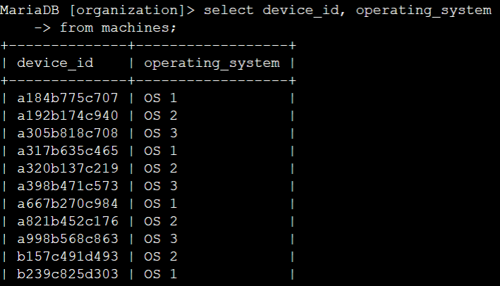

## Retrieve a list of the machines with OS 2

In this task, I need to obtain a list of all machines with the 'OS 2' operating system because these machines need an update. To get this information, I’ll run your first SQL query with a filter.

Select all the records from the machines table with a value of 'OS 2' in the operating_system column.

I use the following commands to retrieve the information:

SELECT device_id, operating_system

FROM machines

WHERE operating_system = 'OS 2';

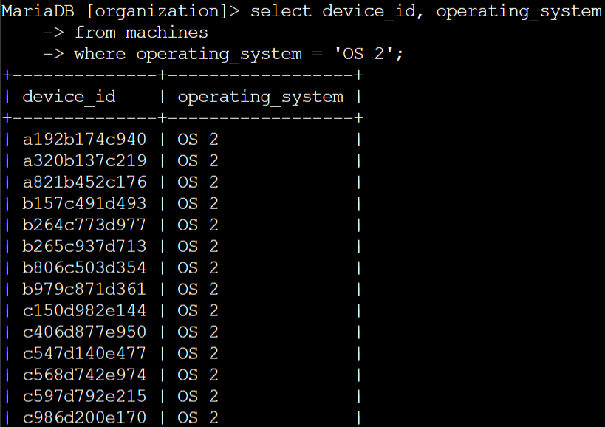

## Task 3. List employees in specific departments

In this task, I need to retrieve a list of all the employees in the Finance and Sales departments to obtain their office numbers. A notice about handling confidential financial information will be posted to these offices.

I use the following commands to retrieve the information:

SELECT *

FROM employees

WHERE department = 'Finance';

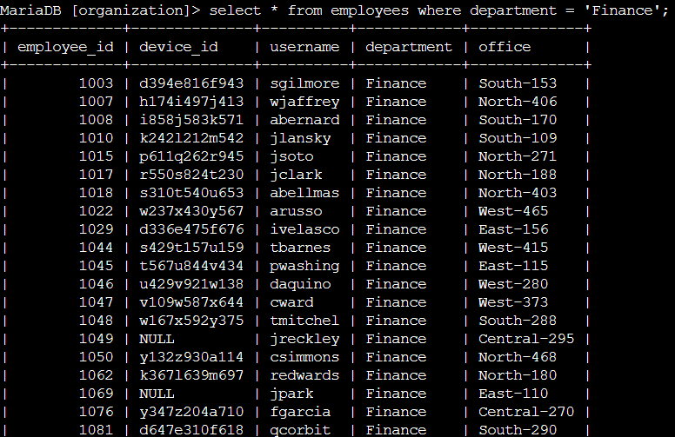

To find out the employees in the sales department.

I use the following commands to retrieve the information:

SELECT *

FROM employees

WHERE department = 'Sales';

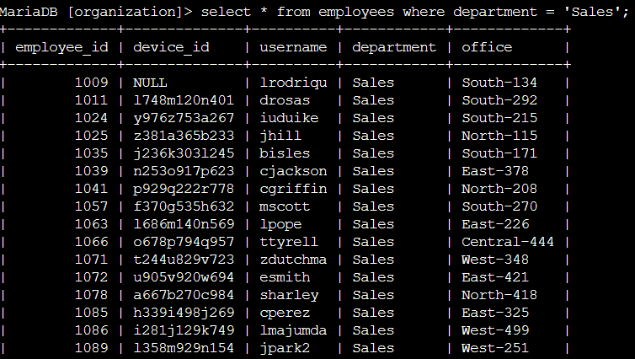

## Task 4. Identify employee machines

My team recently discovered that there are issues with machines in the South building. In this task, I need to obtain certain employee and computer information.

A machine in 'South-109' has an issue. I need to determine which employee uses that computer so you can send them an alert.

I use the following commands to retrieve the information:

SELECT *

FROM employees

WHERE office = 'South-109';

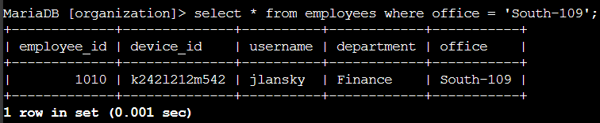

Next, my team has determined that there is an issue with all the machines in the South building. Offices in the organization are named with the building name, a hyphen, and the office number in that building (for example, 'South-109').

I use the following commands to retrieve the information:

SELECT *

FROM employees

WHERE office LIKE 'South%';

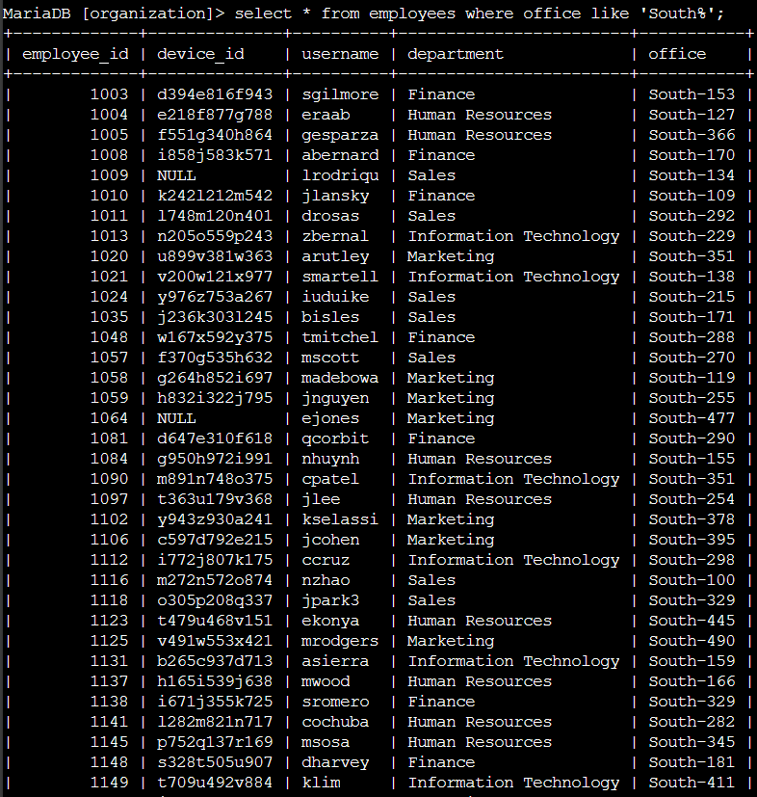

## Summary

Now I have demonstrated practical experience in using SQL to run SQL queries to retrieve information from a database and apply WHERE and LIKE operators to filter SQL queries.